PROTOTYPE RAPID - HFT

I think it’s common knowledge now that Theoben are looking to market a Rapid that fits the HFT bill and I’ve been one of the lucky shooters to be given one to test and evaluate. Here is a review of this gun based on my experiences with it so far.

First off I ‘d like to say a big thank you to Darren Godfrey at Theoben for all his help and generosity and superb service. I spent a morning at Theoben watching my gun get built and it was a case of ‘what do you want?’! Try this, no, OK, this then and so on. Brilliant! To the best of my knowledge there are 3 prototypes out with HFT shooters, all in various disguises to suit the individual tastes. The one I’ve opted for is shown below.

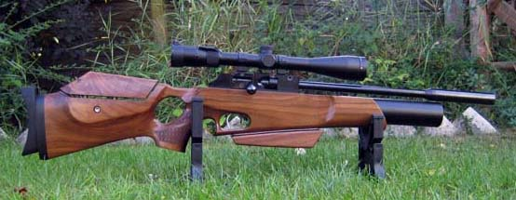

General Overview:
Basically, the action is an MFR one, with standard reg and a 280cc bottle. There are no internal changes other than Darren polished the trigger sears for me. I hope Theoben will incorporate this procedure as standard as its very beneficial in my books! One other thing, on Darren’s suggestion, was to put a heavier inertia weight in the hammer to help reduce hammer bounce. If it works I couldn’t tell you!
On the front end is an old can from the Sirocco, which was put on just to give the gun a better look. You can unscrew the end cap and add a silencer to it for hunting if you wish.
The most notable change is an ambi thumbhole adjustable stock! This was essential in giving me the adjustments required to ensure correct fit, a must for any target shooter. The hamster shown is of my own creation and is just temporarily stuck with Velcro to the underside of the forend, this to aid my standers and kneelers.
The barrel shown is 16” in length and it has had 2 fitted to it so far, an Anschutz and a Walther Lothar, both from Theoben. The Anchutz was fitted originally but I have since pinched the Walther Lothar off my Elan as a comparison. More on this later.
The bolt handle is a new good-looking teardrop design and very nice to use as well. And lastly there is a new single shot tray adaptor, round in shape to allow personal setting of angle for loading and works for lefties too. Overall weight with scope is just over 9 lbs.

Stock:
Theoben have 2 adjustable stock options at the moment, the one I’ve got comes with a Schnabel forend, the other being the Tactical which came out fairly recently. Both have adjustable cheek pieces and butt pads. The butt pad on the Tactical is adjustable up and down and rotates on the bore axis whereas mine did not rotate. As I found the gun always slightly canted when seated naturally in my shoulder I soon modified the butt pad to correct this! A useful feature to have in my opinion.
The cheek piece on mine is adjustable in the usual manner with a single set bolt in the side of the stock plus it can be moved horizontally left and right a little. Some people might want a bit more here, another slight mod by Theoben would be nice! The finish and grain on my stock is good, however internally I found the inletting pretty rough which was to prove a problem - more on this later.
The ambi design has a bridge from the cheek piece to the back of the action which I found a little strange at first when shooting thumb up as I’m used to my thumb in the middle, not off to the side. When holding the grip with thumb through the hole I also found it a little uncomfortable as the underside of the bridge rubs on the top of my thumb. Another slight mod here needed to improve fit!
Aside these two options you also have the standard MFR or Rapid stocks! So, choices to be had!
If you’re like me I’ve generally found Rapids to be nose heavy but with the adjustable stock the weight of the gun has now shifted back towards the trigger due to all the ancillary bits at the back end and balance and handling is greatly improved.

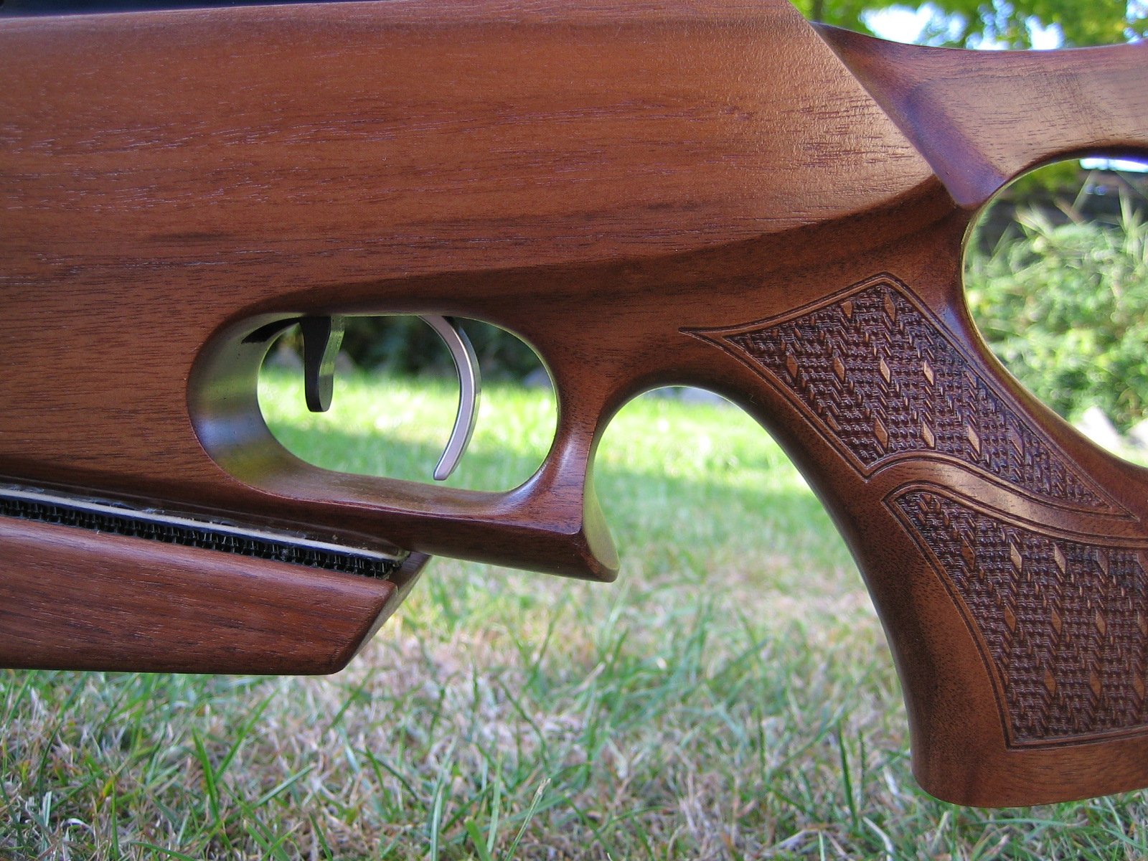

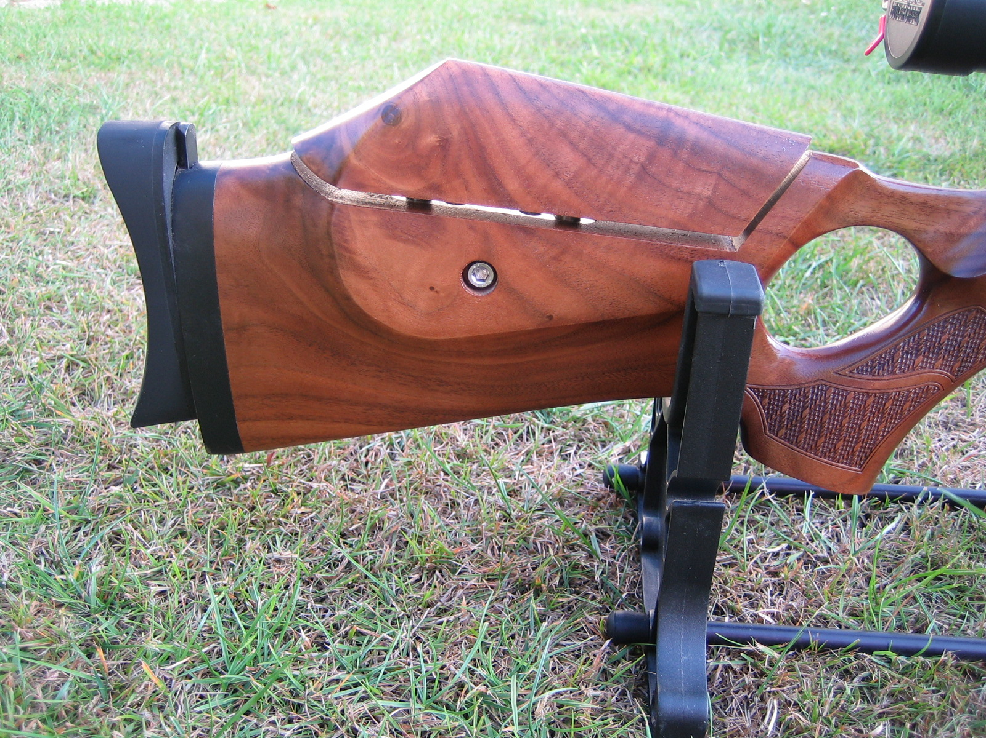

Below: Thumbhole Bridge in center
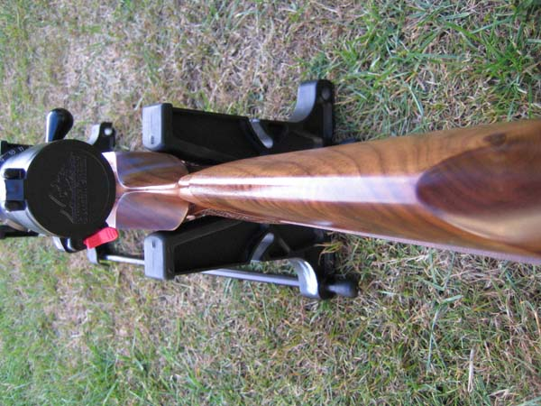

First Test:
Well, after finishing at Theoben I raced down to Pete’s farm to see what I had! With a good selection of pellets, plenty of air and some mates coming with their collections I was looking forward to a great evening!. I arrived at 3.00pm and did my usual when setting up a gun, left at 1.00am! The course of the evening can be best described as very frustrating but with glimmers of hope of a short and compact, well-balanced and accurate gun.
Over a 1000 pellets of running in and some serious brainstorming, adjustments, scope changes etc I sort of realised that the stock was causing the gun to shotgun! Occasionally you could put pellet on pellet at 50 yds, max of 4 and then ‘Whoa! That’s 2” off! In any direction! My mates tried too and both gave up! I’m the type who doesn’t let a gun beat me until I’ve tried everything I know possible. Saturday was spent taking off high spots around the bottle area, though none were actually touching, and trying to pack a badly inletted floor where the action sits. The action would drop into the slot about 80% of the way and then become very tight. The stock holding bolt had to be used to pull it all the way down onto the bed. This obviously affected the action workings somehow as after routing out the sides a bit and some good advice from Sparky; I had a gun at last! Got it zeroed, chronoed a string and put it in the cupboard ready for the Nationals the coming weekend hoping it wouldn't let me down! It didn’t!
I don’t know much about the finer workings of the internals but in comparison to my BTAS Elan the Rapid shoots completely differently. It’s sharp and crisp in firing, whereas my Elan is soft and subdued. It has almost no recoil but its straight back along the bore and more importantly there is no muzzle flip. My Elan, although much more gentle, does! There is a definite appeal to the ‘feel’ of this Rapid in the way it shoots and most of the people who have shot it say they like it! It certainly has character unlike some ‘dead’ ones I know.
Below are results of the 30 shot string done once gun was shooting straight. Filled to 200 bar, shot about a dozen pellets through it and then started the string. Mossies were pellet of choice and weighed.

- Max velocity - 809.9
- Min velocity - 804.7
- Average - 806.9

A variation of 5.2 fps I thought was excellent! Very similar to my Elan which has always been a good gun.
The trigger is the MK4 version and with polishing and correct setup I have a very light but predictable trigger that enables me to release my shots when I want to! Theoben have definitely come a long way on this front.

Other Bits
The round single shot tray is a definite improvement on the rectangular one as you can set it at whatever angle you like to drop the pellet in. Lefties should find this very useful. Again on Sparky’s recommendations a slight mod was done to it at Theoben where the edges of the grove were milled off to stop skirt damage during loading. This has also improved the way the pellet lands in the adaptor, not as much flipping and getting stuck.
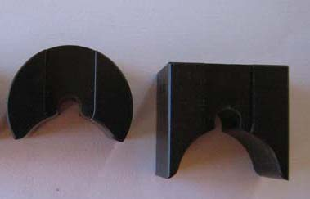
Above: New and old. Note the milled edges before polishing up grove.

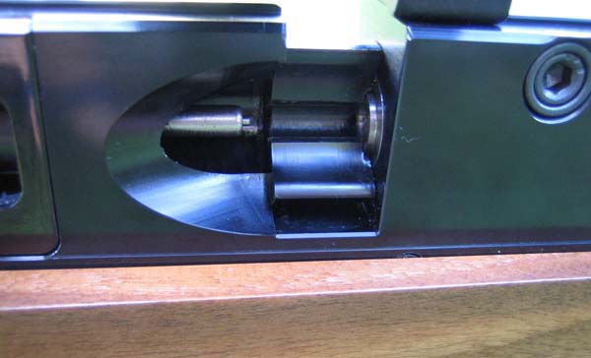Adaptor positioned right side
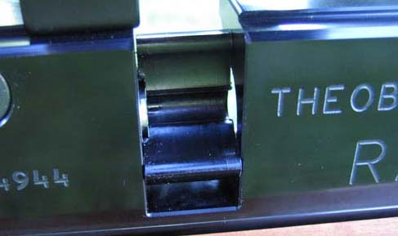Left side

The other nice feature I like is the new shaped teardrop handle. It’s easier to work, smooth to touch but grippy at the same time and I definitely prefer it to the original. I believe Theoben made 30 or so and they sold very quickly! I got the last one! They will be doing more though.
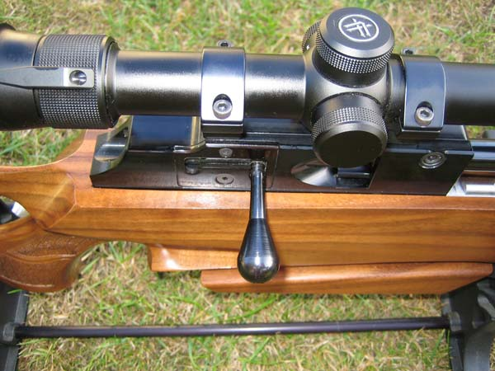

Barrels:
As stated earlier, the gun came with an Anschutz barrel, of which Theoben are pretty much all out of. I believe erratic supply problems were the reason they changed to Walther Lothar. My Elan came with a .20 Anschutz barrel and this is a superbly accurate one. However when I started HFT I decided to go .177 and purchased a Walther Lothar barrel from Theoben that Ben Taylor fitted for me. It was very good for a while and then my groups started opening up. No matter what I did I couldn’t get it back on song so took the gun back to Ben who gave the barrel a “squeeze’ at the choked end and said try that! Well, had to change pellet brand and got my groupings back! So it was with high hopes that the .177 Anschutz barrel would perform as well if not better and after initial running in, it seems to be delivering. But, being the curious sod I am, I had to see if my Walther Lothar barrel on the Elan would perform as well on the Rapid. Changed them over and apart from each preferring different fodder I couldn’t tell the difference in accurarcy. I’ve shot some deadly MFR’s recently, all with Walther Lothar barrels, so I think it’s more a bit of a lottery when buying a new gun if you get a good or a mediocre barrel. Barrels are cheap to ‘tweak” or change so consider this first before buying another gun!
Barrels can be threaded for silencers if desired by Theoben and you can also opt for a 14” shorter one! The barrel on my Elan is only 13.5” and with this on the Rapid I had to mess around with different muzzle profiles to get my balance where I liked it. See picture below with shorter setup. I have come to like this shorter version and have been using it for the last three months in comps to good effect.
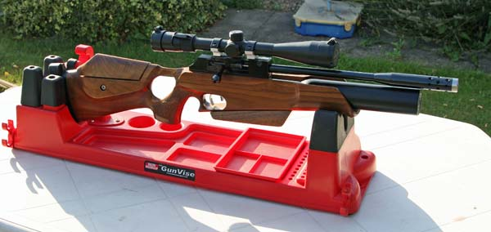

Current Setup
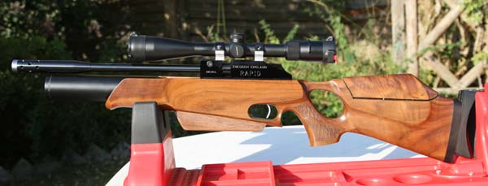

Conclusion:
Theoben have always had a good product in the Rapid range and there are many out there in various forms. It’s a tried and tested platform - why change something that works! With this latest incarnation you get choices, better looks I think, and more importantly a well balanced, compact and fairly light shooting tool. Its ease of maintenance and interchangeable bits plus solid dependability in the field regardless of conditions, coupled with great accuracy, means this has got to be a great HFT gun! As a hunting rig, I can’t see any reason why this can’t be as good as it is a HFT gun. Attach a sling, silencer and slap a few mags in your pocket and off you go!

Talking of mags, I have asked Theoben if they can produce some lower mounts, a slight benefit for the shorter ranges in HFT but this will stop the use of mags due to reduced clearance. Not a problem if gun is solely for competition work but something to consider if wanting to hunt as well. I managed to get a mil finish blank set to try, see picture below. These lower the scope by 4mm on the 1” rings. Theoben will be making a batch of 50 soon I believe. There are no plans for the 30mm mounts as only 2mm can be milled off, not really a big enough difference.
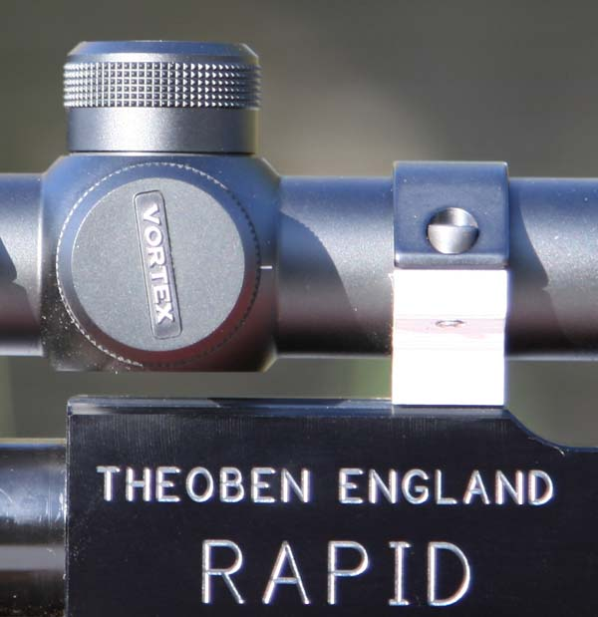

Now, the big question - what price?
Theoben are not sure yet but think it will be in the £900 to £950 range depending on what stock option you want. That’s slightly cheaper than a Daystate MK4 Thumbhole and just a little more than the standard MFR. Personally, I think the timber on these new MK4’s is far superior in finish and looks than the Theoben’s and I think this is the Rapids achilles heel. All of us want an accurate and reliable gun BUT its got to look good too! No one buys an ugly gun! Having used this gun in the latter half of the UKAHFT season I have come to really enjoy the way it shoots but I will be fitting another stock, probably one of my own making as I cannot quite completely get on with this one in certain positions. I believe the Tactical stock is favoured more with the other testers but it’s a case of quality/looks again.
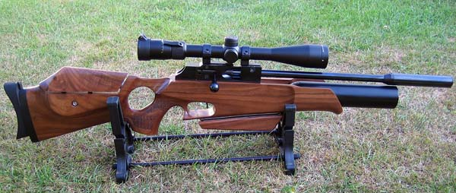

Theoben are listening to shooters and are willing to take on board ideas and suggestions, unlike most manufacturers, so this has got to be a massive plus for us shooters. I’m on an HFT circuit most weekends so anyone interested in trying this particular gun is welcome, just come and ask.

